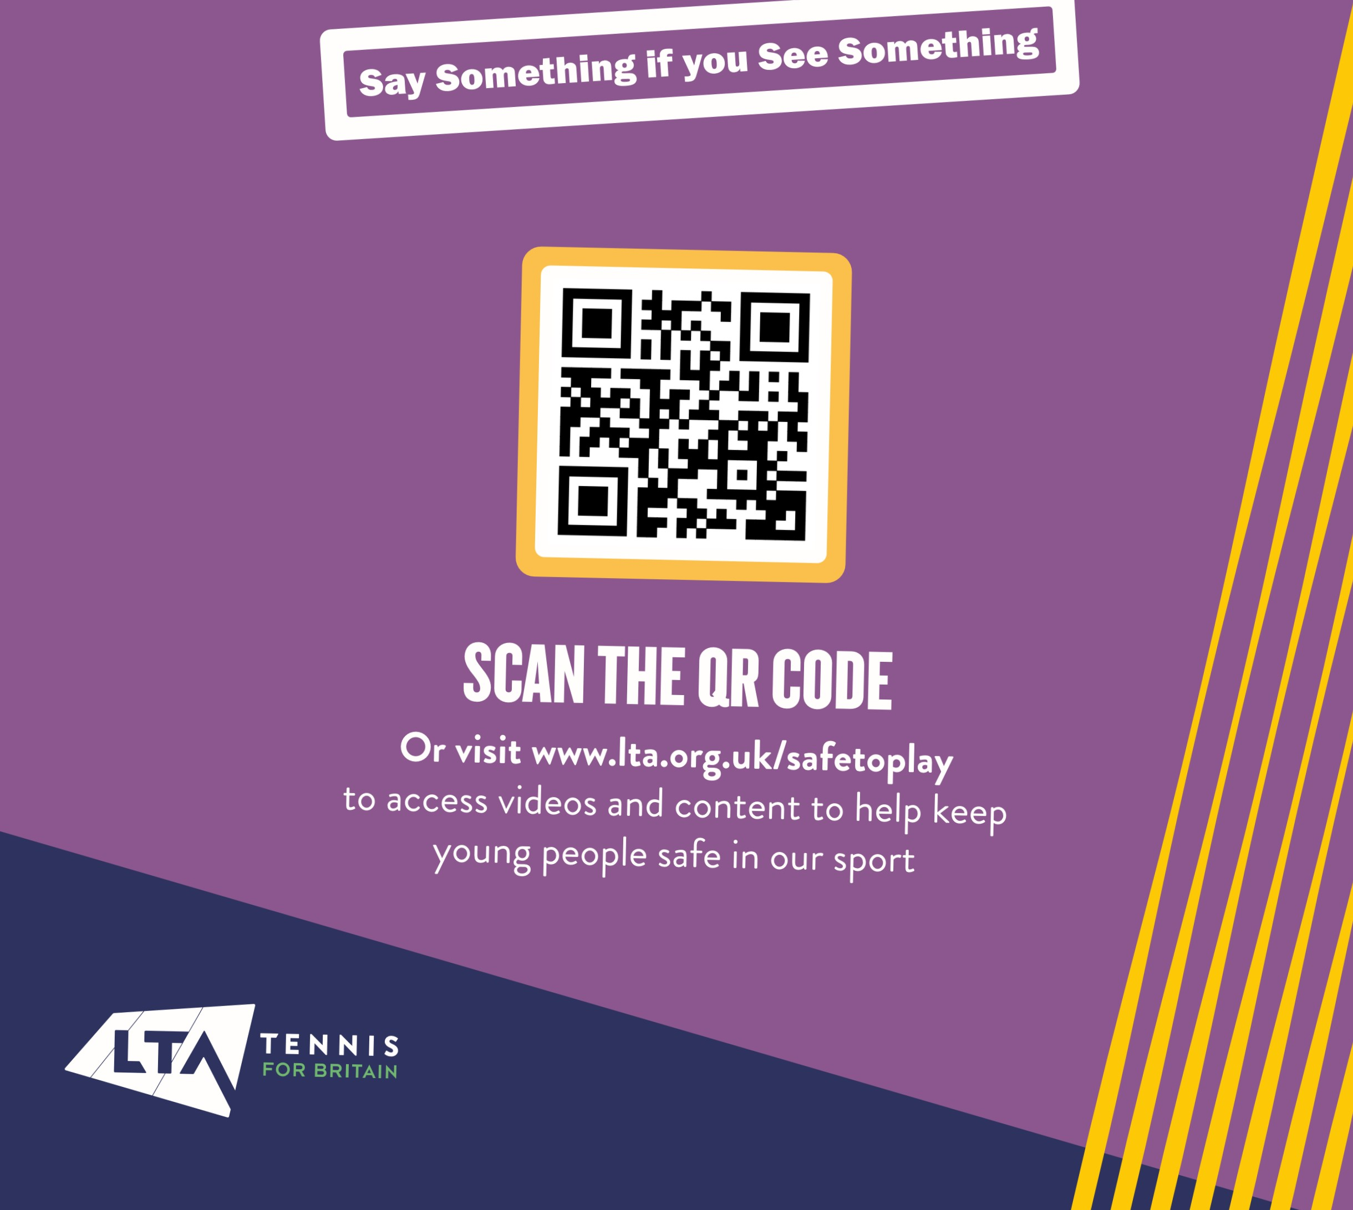
HELP KEEP CHILDREN AND YOUNG PEOPLE IN TENNIS AND PADEL

